**University of Petroleum and Energy Studies**

School of Computer Science

Department of Cybernetics



**Graphics & Animation Tools**

**LAB FILE**

**(Session: 2020-2021)**

**Course:** B. Tech with Specialization in Open Source and Open Standards

**Batch:** 2017-2021

**Semester:** VIIth

**Submitted By: -**

Ananya Raghav

Roll No: R100217008

SAP ID: 500062570

**Submitted To: -**

Dr. Durgansh Sharma Assistant Professor

Department of Cybernetics

**Experiment-4**

**Aim:** Design your own animation using GIMP

**Steps followed:**

1. In order to create a simple animation download or draw the images which you want to use in the animation.
2. Save those images in your laptop.

(You can choose any number of images you want.)

1. Open GIMP
2. Select File 🡪 Open as Layers 🡪 Select all the images 🡪 Open

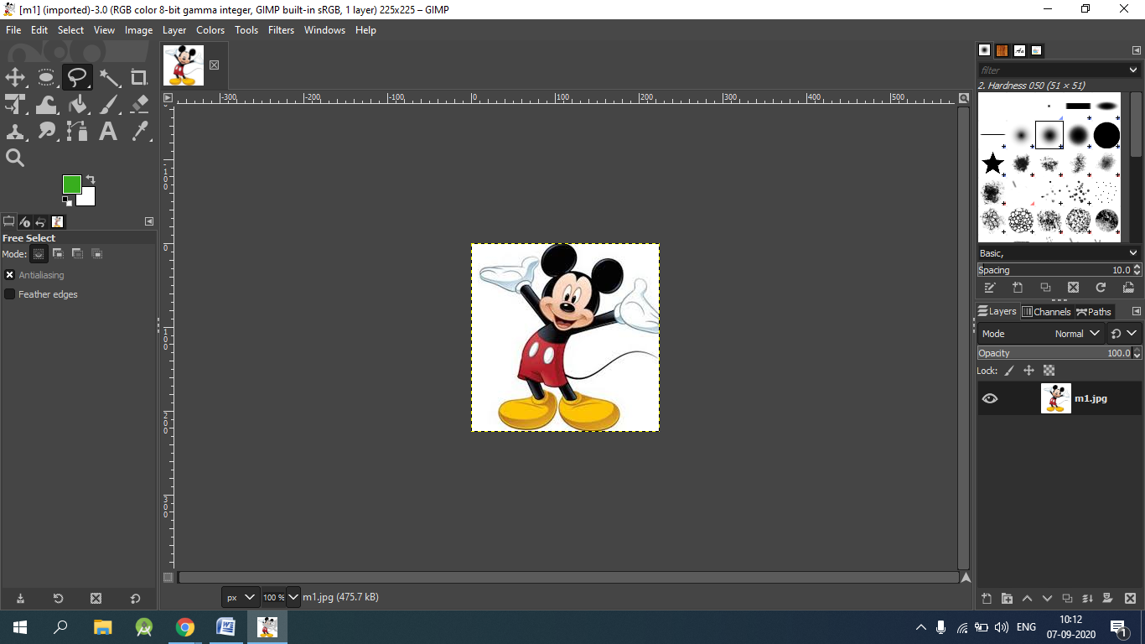

1. Now, in layers tab order your images

The sequence starts from bottom layer to the top.

1. Go to main menu and select filters option 🡪 then select Animations 🡪 Optimize for GIF.
2. To view GIF, go to Filters 🡪 Animations 🡪 Playback.

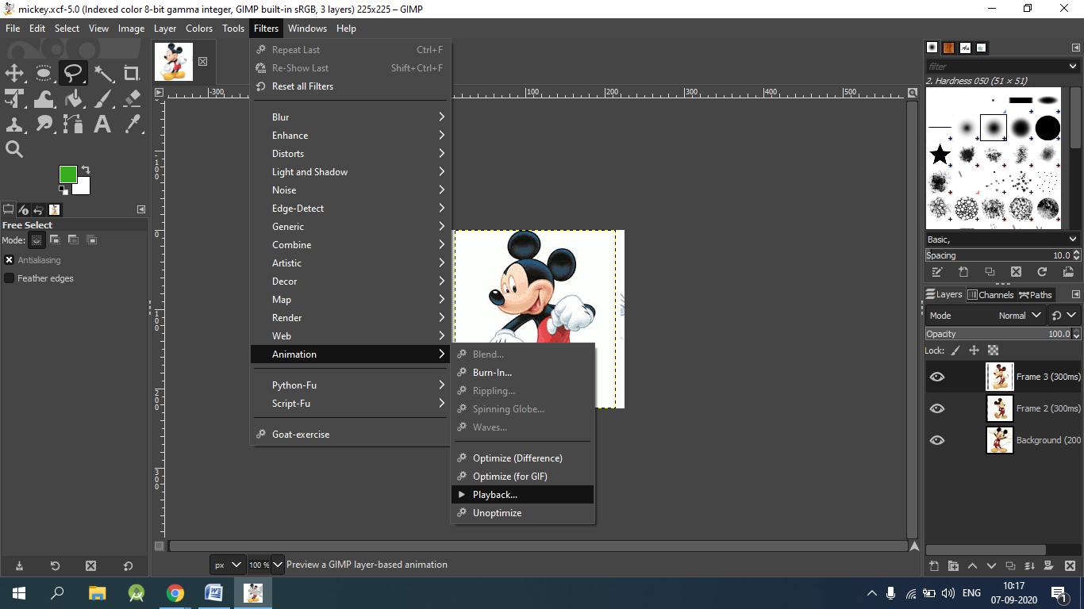

1. Press the play button to view your gif in the dialog box.

(You can change the properties of the layer by right clicking on the layer and then selecting Edit layer attributes.)

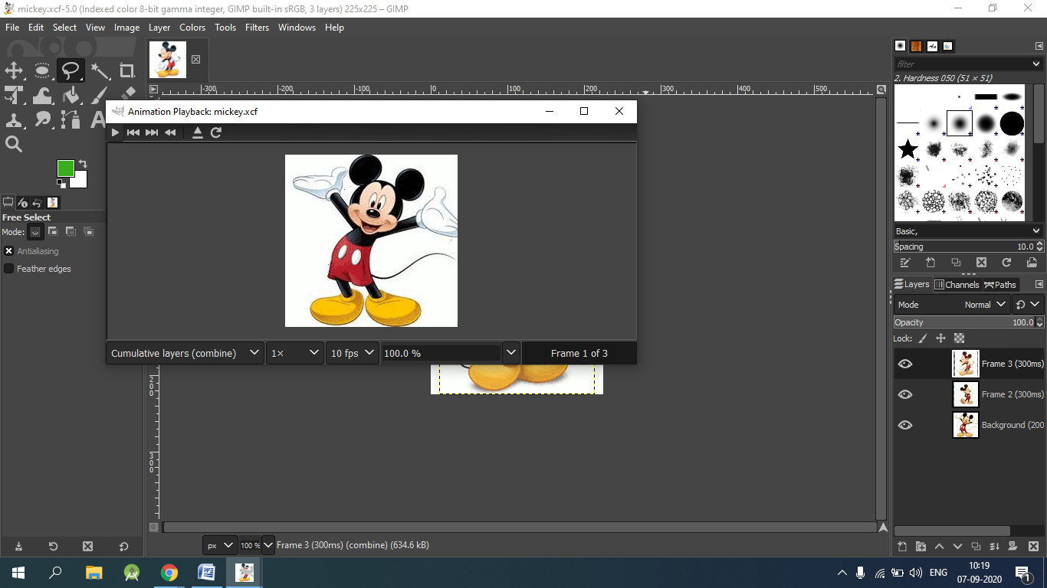

1. To save file, Select File 🡪 Click Export As
2. Name your GIF and choose folder  🡪 Select File Type 🡪 Click GIF Image.

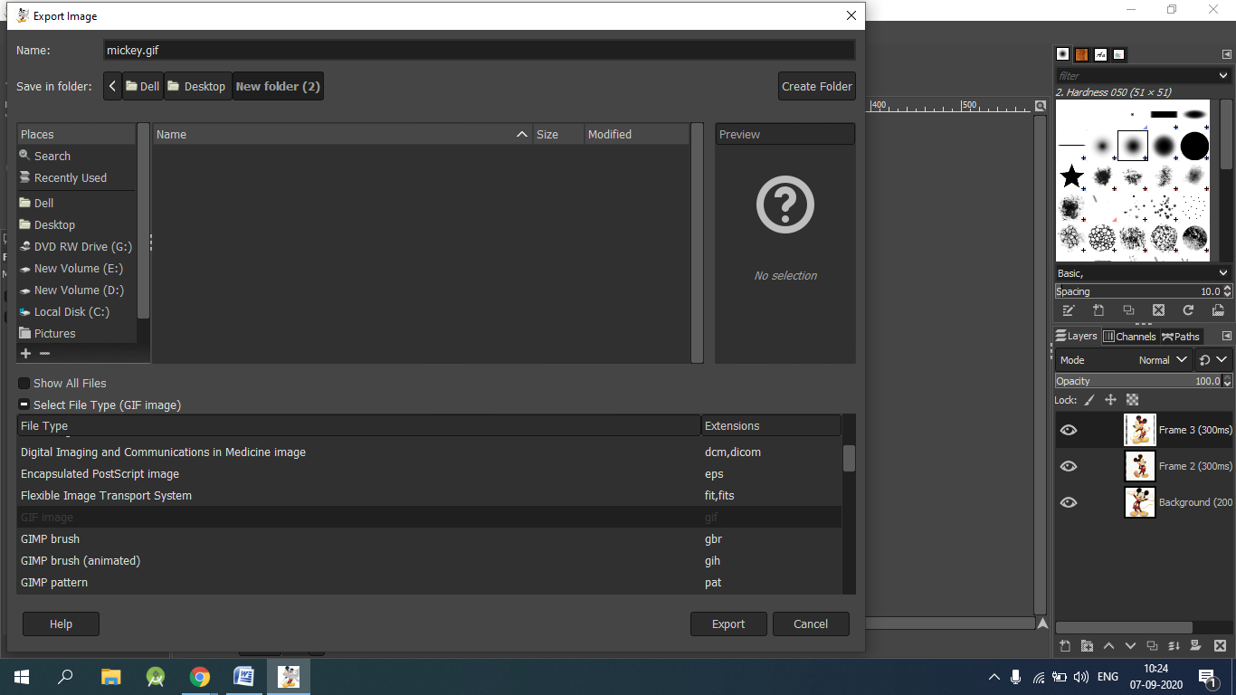

1. Select ‘As Animation’ 🡪 Select Loop Forever 🡪 Click Export.

**Images Used-**



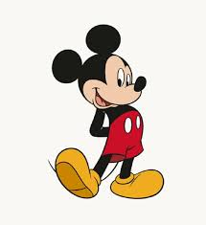



**Output:**

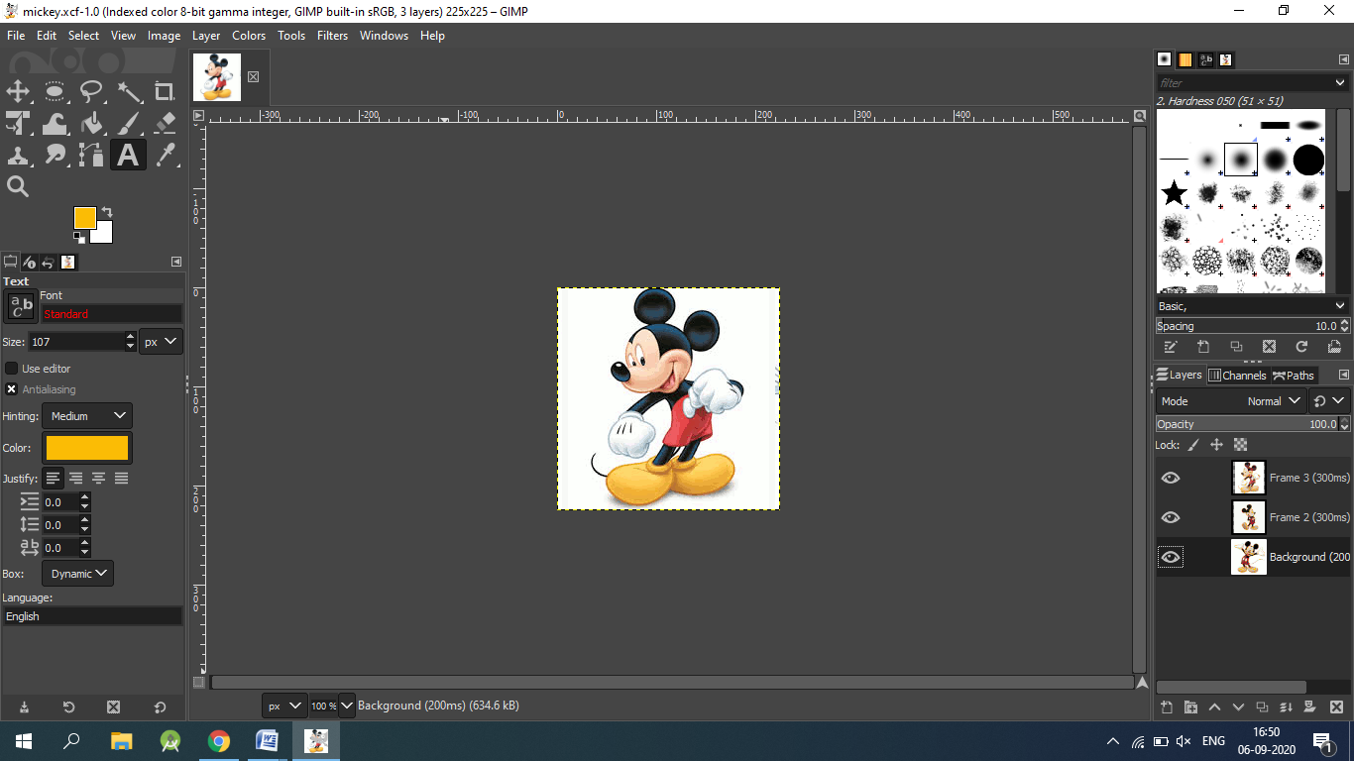

**GIF-**

